1. **INTRODUCTION**

Our Job Portal project is a website where people who want to find a job can create their profiles and search for job openings that match their skills and preferences. Employers can also use the site to post job vacancies and search for potential candidates. It's a digital meeting place that helps job seekers and companies connect easily, streamlining the job search and hiring process

1. **OBJECTIVES**

The main objective of the project on Job Portal System is to manage the details of Employer, Employer Registration, Post Job, Interview, Search Job. It manages all the information about Employer, Call Letters, Search Job, Employer. The project is totally built at administrative end and thus only the administrator is guaranteed the access. The purpose of the project is to build an application program to reduce the manual work for managing the Employer, Employer Registration, Call Letter, Post Job, Interview. It tracks all the details about the Post Job, Interview, Search Job.

* **Connect Job Seekers and Employers:** To bring together people looking for jobs and companies offering positions.
* **Job Posting and Search:** Allow employers to post job openings and job seekers to search for relevant positions.
* **Resume and Application Submission:** Enable job seekers to submit their resumes and applications for jobs.
* **Matching:** Provide a matching mechanism to help job seekers find suitable jobs and employers find suitable candidates.
* **Communication:** Facilitate communication between job seekers and employers for interviews and hiring.
* **User Profiles:** Create and manage user profiles for both job seekers and employers.
* **Notifications:** Notify users about relevant job openings, application status, and interview requests.
* **Data Management:** Store and manage job listings, resumes, and user data securely.
* **Feedback and Reviews:** Allow users to provide feedback and reviews about their experiences.
* **Analytics:** Provide data and insights to help both job seekers and employers make informed decisions.

1. **FEATURES**

* AI-Powered Matching
* Skill Assessment Tests
* Freelancer Opportunities
* Virtual Job Fairs
* Real Time Chat and Messaging
* Multi-languages Support
* Video Interviewing
* Easy to Update Information
* Work Becomes Very Speedy
* Various level of reports available with a lot of filter criteria’s

1. **TOOLS/ENVIRONMENT**

**Hardware Requirement:**

Processor: Pentium IV

Processor speed: 2.80 GHZ

Storage: 500 MB RAM

Hard disk: 500 MB

**Software Requirement:**

Front end: Full Stack

Database: PHP

Operating System: Microsoft Windows XP, 10 above

1. **ANALYSIS DOCUMENT**

**Data flow Diagram:** A data flow diagram (DFD) is a graphical representation of the “flow” of data through an information system.

**Zero Level DFD:** It is also known as a context diagram. It’s designed to be an abstraction view, showing the system as a single process with its relationship to external entities. It represents the entire system as a single bubble with input and output data indicated by incoming/outgoing arrows

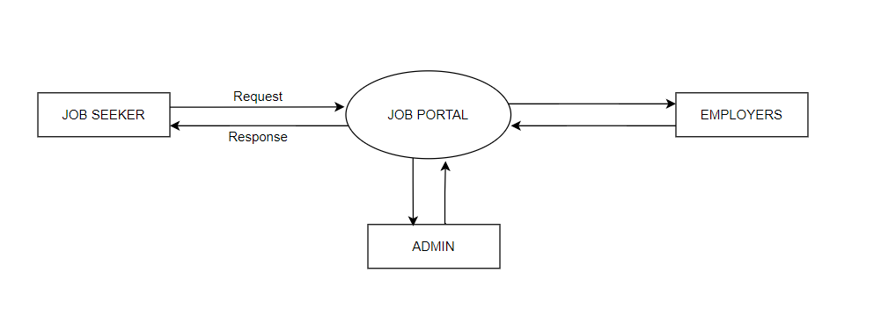

**1st Level DFD:** In 1-level DFD, the context diagram is decomposed into multiple bubbles/processes. In this level, we highlight the main functions of the system and breakdown the high-level process of 0-level DFD into subprocesses.

1. **FLOWCHART**

A flowchart is a visual representation of the sequence of steps and decision needed to perform a process. Each step in the sequence is noted within a diagrammatic shape. Steps are linked by connecting lines and directional arrows, this allows anyone to view the flowchart and logically follow the process from beginning to the end

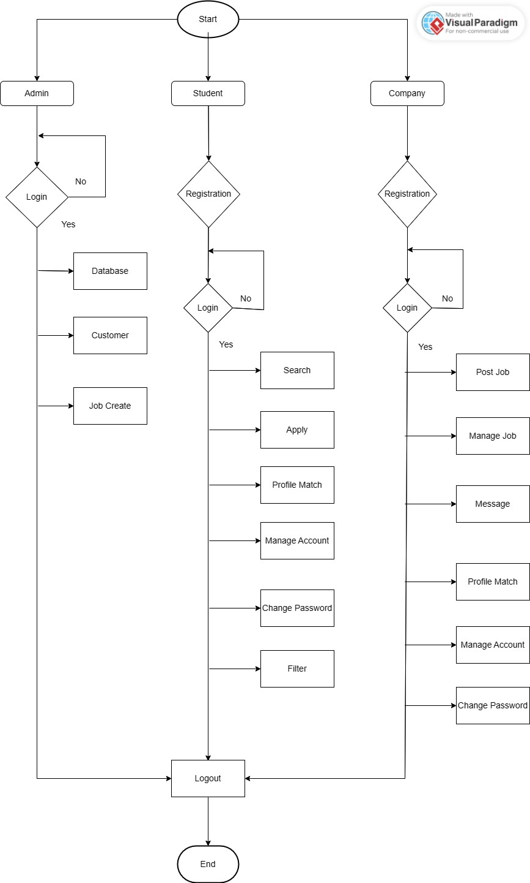

1. **GANTT CHART**